M

**Jedi of the Month:**

**Rianna R.  
Shane H.  
Sawyer B.  
Jacob P.**

**Melany H.**

1. screen
2. scrape
3. scratch
4. scream
5. strong
6. straight
7. strange
8. stretch
9. strict

10.strength

11.stream

12.strap

13.spring

14.spray

15.sprout

16.spread

17.sprain

18.scrap

19.stress

20.stripe  
 **Test is Friday, January 12th!**

# Word Study:

January 3rd-5th 2018

Third Grade   
 Newsletter

IMPORTANT Reminders:   
**-HAT DAY= (Fridays) (You must pay $0.50 to wear a hat.)  
-Snack Cart= (Fridays) (bring money, snacks are $0.25-$1.00).  
  
-Tues. Jan. 9th Report Cards Sent Home!**

**-NO SCHOOL January 15th-Martin Luther King Holiday!  
-Tues. & Wed. Jan. 30th-31st NWEA MAP Testing!**

What We’re Learning:

**Reading: Recounting/Theme**

**Writing: Opinion Piece  
 Math**: **Fractions**  
 **Social Studies: Economics**

Teacher Contact:  
[leslie.thomas@bullitt.kyschools.us](mailto:leslie.thomas@bullitt.kyschools.us)  
[shelby.janes@bullitt.kyschools.us](mailto:shelby.janes@bullitt.kyschools.us)  
erica.walker@bullitt.kyschools.us

EMPOWERING STUDENTS TO SOAR!   
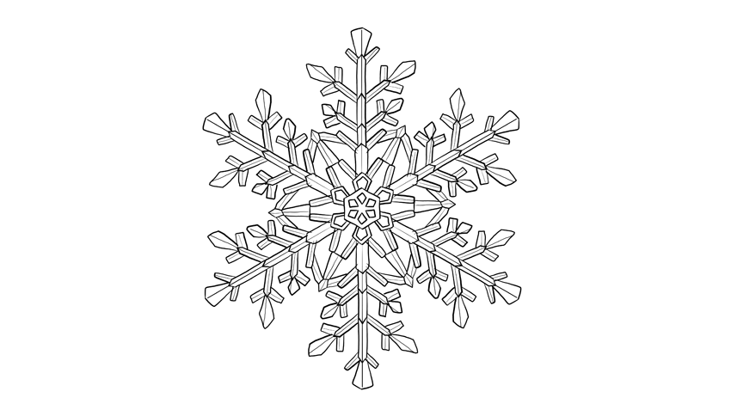

**Lunch:   
11:35-12:00**

Special Area Rotation this Week:

***Red*** Week

Janes: Arts/Humanities

Thomas: Science

Walker: P.E.

**Check out our website for lesson plans and resources.**

**http://freedomthirdgrade.weebly.com/**